The first researchers have a similar project called “Expert System for Hotel Booking System” which have a problem like our client which is book hotel services or planning activates. Hotel services are rarely unavailable in traditional booking systems. Furthermore, booking systems lack a tool for planning appropriate activities in the immediate vicinity of the hotel. The Researchers planned expert system’s basic goal is to connect the hotel with nearby sites, activities, and interesting events. [1].

The second researchers have a familiar project called “Design and implementation of an online booking system for a cinema house” which make a reservation or appointment for a service via the Internet. The goal of this project is to create an online booking system for movie theatres, mostly in Nigeria. Furthermore, the full implementation of this project will improve the Nigerian movie booking system.

The last researcher’s project called Lila Booking System provides the ability to plan access to remote experiments or to put it differently. The portal will collect comments from students in order to determine their knowledge and learning success, as well as to determine whether the experiments are appropriate for their needs.

This website page in figure 2 above is about online booking system which have online booking and accept payments.

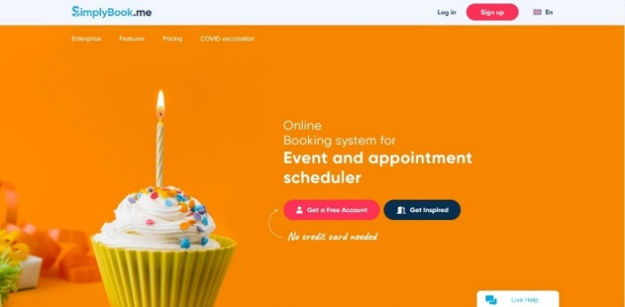This web application page in figure 3 in top about online booking automation which provides tours, courses, classes, activities, and events.

